**Week 2 Topic Outline  
Chapter 2 – Intelligent Agents** …and other stuff perhaps not quite as intelligent as the agents mentioned in the beginning part of this subtitle.

1. Terminology
   1. **Agent** – anything that can be viewed as perceiving its **environment** through **sensors** and acting upon that environment through **actuators**.
      1. ??? – Using that definition, name some agents that exist in any game, computer system, etc.
   2. **Percept** – perceptual inputs…how the agent gets information from the environment.
      1. ??? – Using the examples from before, what would the percepts of those agents be?
   3. **Actuators** – the tools the agent uses to take action in the environment.
      1. ??? – What are those agent’s actuators?
   4. **Agent Function** – specifies the action taken by the agent in response to any percept sequence. Illustrated by the figure below:

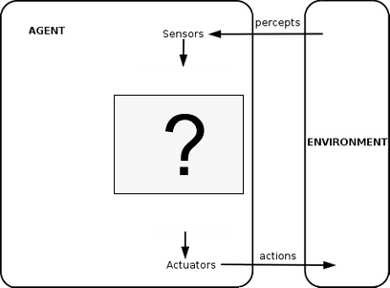

* 1. Vacuum cleaner world – a (very) simple example. p.36
     1. Look at figure 2.2 and 2.3
  2. **Environment State** – a snapshot of the characteristics of the environment
     1. ??? – environment states in the vacuum cleaner world?
  3. **Percept Sequence** – the entire history of what the agent has perceived.

1. Behavior
   1. Agents are rational if they seek to do the “right” thing.
      1. ??? – what does it mean to do the right thing?
      2. ??? – How do we evaluate whether an agent did the right thing?
   2. **Performance measure** – how a series of environmental states are evaluated. An agent selects an action/series of actions, and each action will cause the environment’s state to change.
      1. *When you’re coming up with your own performance measures, it’s better to design with the desired outcome in mind, rather than how you think the agent should act.*
   3. **Rational Agent** – (book definition) – for each possible percept sequence, a rational agent should select an action that is expected to maximize its performance measure, given the evidence provided by the percept sequence and whatever built-in knowledge the agent has.
2. Discussion – Mario-NES style! Let’s say we’ve been tasked with rewriting the AI script for the enemies in Mario.
   1. Define the environment and what the agent (enemy) knows/can perceive
   2. What are the “right” actions for the agent to take?
   3. Define a performance measure
   4. Is the agent rational? How do we know?
3. Discussion…back to the vacuum world (p. 38). Let’s say:
   1. *Performance measure gives one point for each clean square at each time step, over a period of 1000 time steps.*
   2. *The bounds/geography of the environment is known, but the dirt distribution and initial location of the agent are not.*
   3. *Agent actions: left, right, clean(suck)*
   4. *The agent can correctly perceive its location and whether that location contains dirt.*
   5. Ok – using those rules, would you say that the agent is rational? Justify your answer!
      * 1. We know that a rational agent seeks to do the “right” thing.
        2. The “right” thing is defined by the performance measure
        3. This performance measure awards points based off of the number of clean tiles
        4. The agent’s actions seek to do that = rational
   6. ??? – What will the agent do once all the squares are cleaned? Is that rational?
   7. What if we changed the performance measure to include a loss of a point for each movement (left/right) that was made? Would the agent still be rational?
4. Break
5. Quick Review

|  |  |  |  |  |
| --- | --- | --- | --- | --- |
| Agent Type | Performance Measure | Environment | Actuators | Sensors |
| Taxi Driver | Safe, fast, legal, comfortable trip, maximize profits | Roads, other traffic, pedestrians, customers | Steering, accelerator, brake, signal, horn, display | Cameras, sonar, speedometer, GPD, odometer, accelerometer, engine sensors, keyboard |

* 1. This table is known as a PEAS description.
  2. There are additional PEAS descriptions on page 42.

1. Independent practice
   1. <http://www.axis-games.com/dodgeballin.php>
   2. Establish known information (information that the agents can perceive/know)
   3. Write a performance measure for the agents in the game
   4. Based off of your performance measure, are the agents rational?
2. **Omniscience** – Knowing the *actual* outcome of actions instead of the *expected* outcome.
   1. Rational agents choose actions based off of an expected outcome
   2. Omniscient agents choose actions based off of what they know will happen
   3. Is omniscience impossible in reality? In programs/games?
   4. Good test questions – compare contrast the characteristics of omniscient and rational agents
3. Additional characteristics
   1. **Fully vs. partially observable** – do the agent’s sensors give access to the entire environment or just part of it?
   2. **Single vs. multi agent** – how many agents exist in the environment. This can be tricky depending on how you classify other agents and how each agent views other agents.
   3. **Competitive vs. cooperative** – does an agents behavior maximize its performance while also minimizing other agents?
   4. **Deterministic vs**. **stochastic** – is the next state of the environment completely determined by the current state and action of the agent?
4. **Agent programs**Take the current percept as input from the sensor and return an action to the actuators.



Agent program

1. **Simple reflex agents** – select actions on the basis of the current percept, ignoring the rest of the percept history.
   1. Vacuum agent – its decision is based only on the current location and on whether that location contains dirt.

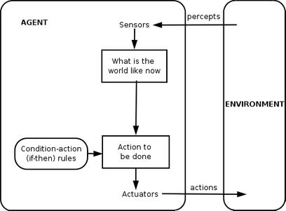

1. **Model-based reflex agents** – makes decisions based off of a model of the world that has been constructed from two types of knowledge:
   1. Knowledge of how the world evolves independent of the agent (so that the agent can keep track of stuff it can’t see right now, but has seen in the past).
      1. “I put my keys in my pocket a while ago. I don’t see them now, but I expect them to be in my pocket still”
      2. “I saw a car in my rearview mirror a few seconds ago. I’m not looking at it now, but I expect that it will be closer to me now than it was when I observed it”
   2. Knowledge of how an agent’s behavior affects the world
      1. “If I turn the steering wheel to the right, the car will turn to the right”

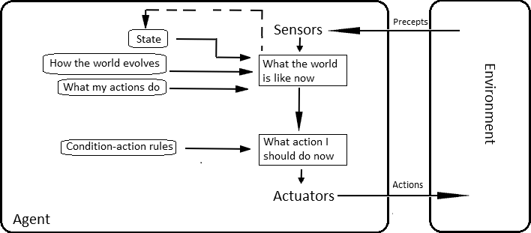

1. **Goal-based agents** – select their action based off of a goal
   1. Also uses characteristics of model-based agent (knowledge of the environment and the effects of its actions on the environment)
   2. This is different from the condition-action rules of the first two types of agent. Goal-based agents consider the future:
      1. “What will happen if I do xyz…?”
      2. “Will that make me happy?” (satisfy/get closer to my goal)

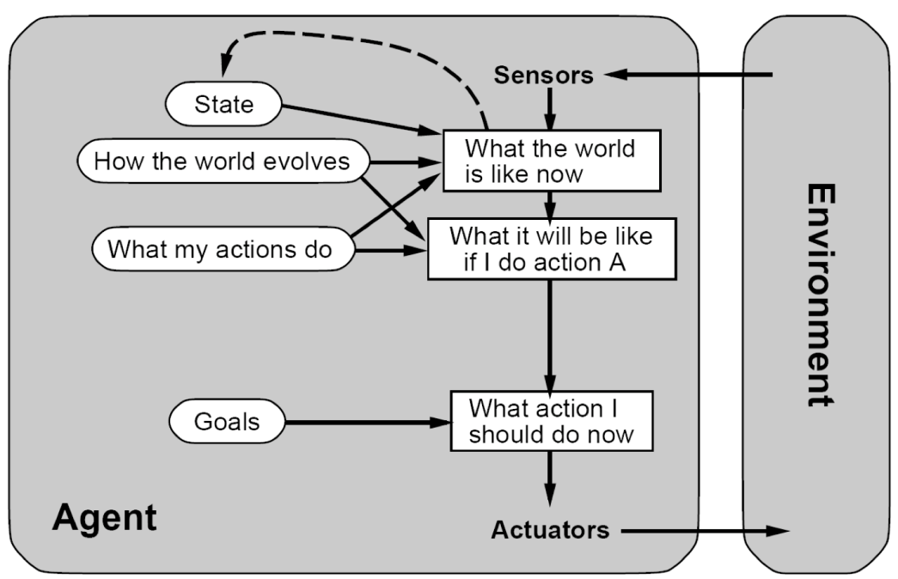

1. **Utility-based agents** – select behaviors that maximize utility (utility is the AI word for happiness)
   1. Goals alone aren’t enough to generate high-quality behavior in most environments.
      1. Think about a Taxi driver who is concerned only with the goal of getting to its destination
   2. Goals are great, but they don’t allow for any gray areas – only “happy” or “unhappy”
   3. **Utility Function** – an internalization of the performance measure. How well the agent thinks he’s doing

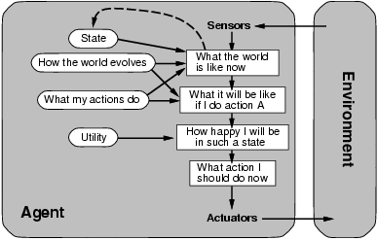

1. Conclusion
   1. So what…..? This is all common sense, but it’s important to formalize terms to better explain some types of agents. This also makes it easier for us to make more complex agents if we have clearly established terms.
   2. Notice that as we talked about the four types of agent, they got more and more complex and built on each other.